RAPIDFIRE: AN INTELLIGENT
DEVOPS CLI TOOL
PROJECT SYNOPSIS
OF MINI PROJECT
BACHELOR OF TECHNOLOGY
Department of CSE

SUBMITTED BY  Vedansh Shrivastava  (Roll No. 2501320100321)  Vaishnavi Sahu  (Roll No. 2501320100319)  Tanwi Gupta  (Roll No. 2501320100311)  Tanmay Mittal  (Roll No. 2501320100309) | UNDER THE SUPERVISION OF  Ms. Ruchika  Project Guide  Department of Computer Science & Engineering
Batch: 2025–2029 | Second Year (3rd Semester)
Greater Noida Institute of Technology, Greater Noida
Dr. A.P.J. Abdul Kalam Technical University, Lucknow
October 2026

INDEX
Section | Page
Notations and Nomenclature | 3
1 Introduction | 4–6
1.1 Background and Problem Statement | 4
1.2 Proposed Solution and Scope | 4
1.3 Architecture and Technology | 5
1.4 Command Execution and Safeguards | 6
2 Literature Review | 7–8
3 Objectives | 9–10
4 Methodology and Planning of Work | 11
5 References | 12

List of Figures
Figure | Page
1 Proposed system architecture | 5
2 Command execution and security flow | 6
3 Iterative development methodology | 11

List of Tables
Table | Page
1 Technology components and their roles | 5
2 Review of related developer tools | 8

NOTATIONS AND NOMENCLATURE
Term | Meaning
AI | Artificial Intelligence
API | Application Programming Interface
CLI | Command-Line Interface
CI/CD | Continuous Integration and Continuous Delivery
CORS | Cross-Origin Resource Sharing
DevOps | Practices connecting software development and operations
DevSecOps | Integration of security into development and operations
JSON | JavaScript Object Notation
LLM | Large Language Model
PTY | Pseudo-Terminal
REPL | Read–Eval–Print Loop
SQLite | Embedded relational database engine
Scaffolding | Generation of a starter project structure and configuration
Secret | Sensitive value such as an API key, token or password
Preset | Saved project template used to reproduce a workspace
TUI | Terminal User Interface; an interactive menu-driven console.
AST | Abstract Syntax Tree; a structured representation of source code.
Fail-closed | A safeguard that blocks an operation when validation fails or is unavailable.

1 INTRODUCTION

1.1 Background and Problem Statement
Existing form of application development requires an entire suite of utilities for application design and development, dependency management, service configuration, source code management, and preparation of the deployment environment. Students or developers who want to build a frontend and backend must plan the setup procedures carefully to prepare the implementation of application features.
Take a common full-stack pairing like React with a Python backend: developers have to keep separate directory trees organized, run independent server commands on different ports, and make sure API calls connect properly. On top of that, juggling git commits across multiple folders creates plenty of chances to push untested changes or accidentally commit private API keys. Since these steps happen over various commands and interfaces, there's a higher chance for a configuration error.
This project aims to answer a simple question - How can everyday development and operations tasks be coordinated within a common terminal without limiting developer freedom, repository choice, or the ability to make security decisions? Focus on standard workflows for students, small teams, and prototypes.

1.2 Proposed Solution and Scope
RapidFire is a modern DevOps CLI that combines a persistent shell with project scaffolding, local service execution, Git support, secret scanning, and repository-aware guidance. The RapidFire command dispatcher is built to separate internal commands from standard shell commands and routes each request to the correct module.
The functionality includes an interactive initialization wizard and setup commands designed for connected frontend-backend applications using CORS and API health checks. Other RapidFire functionalities include a concurrent runner, repository summaries, binary-safe presets preserving .gitignore files, pre-push secret scanning, and a guarded deploy vercel command that checks Git working-tree status. Optional support is also included for large language models to explain code and generate helper files with explicit user approval.
The prototype is mainly designed for reducing repetitive setup steps. Testing will compare against manual setup processes while evaluating platform compatibility, everyday usability, and security enforcement.

1.3 Architecture and Technology
Terminal interaction, workflow orchestration and data storage are separated into different layers. In this architecture, Node.js handles the coordination of child subprocesses [1], while node-pty enables true pseudo-terminal interaction between the process and the terminal [2]. These underlying architectural relationships are presented in Figure 1, where optional AI requests will probably go across the local workspace boundary.
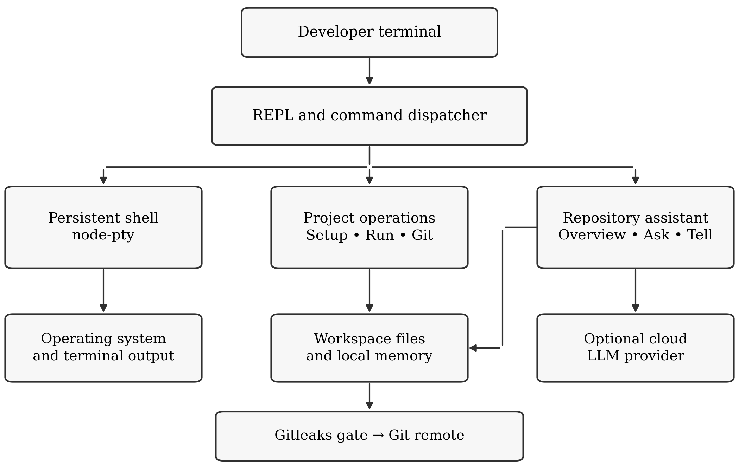
Figure 1. Proposed system architecture
Table 1. Technology components and their roles
Component | Role in RapidFire
Node.js and node-pty | Command routing, persistent shell and process output
Framework adapters | Frontend–backend templates, API wiring and environments
Git and Gitleaks | Version-control operations and local secret scanning
JSON and SQLite | JSON repository context; SQLite CLI audit history and generated-app databases
Optional LLM APIs | Repository explanations and contextual assistance
RapidFire stores its repository summaries in a file at .rapidfire/memory.json, while command history is tracked locally in session logs. Furthermore, SQLite is pre-configured as the default embedded relational database in generated Django applications to support local backend persistence without extra database services [3], [9].

1.4 Command Execution and Safeguards
Built-in RapidFire commands go directly to their dedicated module, while all other commands go straight to the persistent shell. The managed push workflow checks against relevant changes before pushing up to the remote repository. If there was a scan failure, a detected secret, or a rejected remote push, the process is stopped, giving the developer time to investigate more.
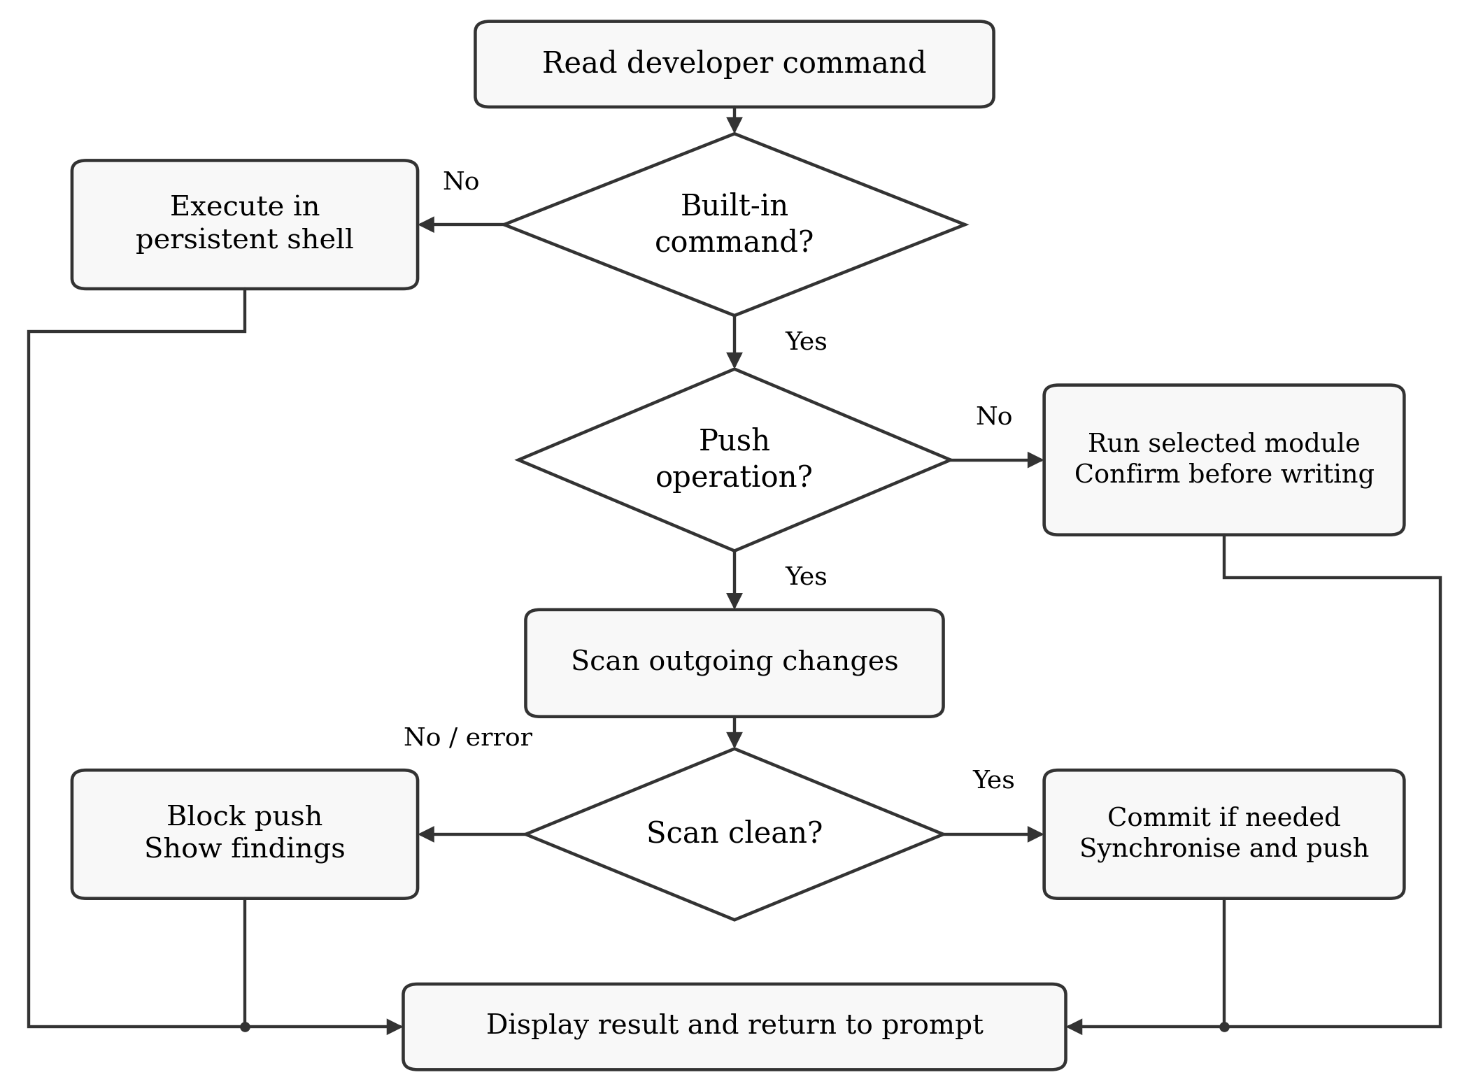
Figure 2. Command execution and security flow
In the case of remote pushes, taking a quick look at just the staged diff is not enough, since secrets committed in earlier commits can easily slip past tools that don't inspect the full outgoing history. RapidFire hooks Gitleaks directly into a Git pre-push hook [4], [5] to catch secrets before they leave the machine. While this technique is less likely to result in a leak, it is best used as an 'extra safeguard' to complement existing confidentiality procedures.
Additionally, regarding local edits, tell shows the change suggestions first and allows developers to review those suggestions before any changes are committed to the disk. When deploying to the cloud, the guarded deploy vercel command runs git status --porcelain to spot any untracked or forgotten files, asking for confirmation before pushing code live. For workspace backups, presets preserve .gitignore rules and turn binary files into Base64 strings so they can be brought back without any byte corruption. On top of that, cloud AI queries only send stripped-down snippets of project context, keeping passwords and local database files safely out of external model prompts [8].

2 LITERATURE REVIEW

2.1 Process Execution and Terminal Integration
You can create and communicate with subprocesses using Node.js's child_process module as shown in earlier work [1]. child_process is used to call out to package managers, framework generators, and local services. Additionally, the Microsoft node-pty project can be used to interact with programs through a pseudo-terminal, with Linux, macOS, and Windows support [2]. Together, these components constitute the essential background needed for a CLI to preserve the experience of an interactive shell while performing more advanced functions.

2.2 Project Scaffolding
Vite provides commands for creating projects and templates for popular frontend frameworks [6]. These generators ease the creation of starter frontend applications. Nevertheless, a complete frontend-backend prototype also requires service configuration, API endpoint wiring, and execution coordination. RapidFire's contribution is a composition layer that connects supported prototypes and verifies their communication.

2.3 Local Secret Detection and Git Hooks
Gitleaks can uncover possible secret information stored in repositories, files, and input text as shown in earlier work [4]. Examples of integrated use cases include local hooks and continuous integration pipelines. By running Gitleaks inside a Git pre-push hook, any non-zero exit code stops the push in its tracks [5]. RapidFire relies on this behavior to scan outgoing code locally before it ever reaches a remote server. The real trick is inspecting the right set of commits and showing clear, actionable warnings so developers know exactly what broke.

2.4 Contextual AI Assistance
According to GitHub Copilot's prompt guidance, adding relevant source context, conversation history, and clear instructions provides the best quality for generated responses, though generated outputs always require human review [7]. RapidFire applies this approach to repository summaries and terminal sessions. To keep things fast, the CLI saves repository details in a local cache so developers do not have to rebuild project context every time they open a new session. In practice, developers must account for stale context, limited repository coverage, and potential model hallucinations, while ensuring sensitive credentials and private data are protected against leakage [8].

2.5 Local Persistence and Comparative Review
SQLite is intended for local application storage and does not require a separate database server process [3]. It is well suited for generated backend prototypes. The JSON memory file of the CLI serves a different purpose: preserving repository summaries and session dialogue context. Atomic file replacement mitigates the risk of partial writes, while Node.js provides the native filesystem operations needed for this kind of local storage [9].
Table 2. Review of related developer tools
Existing work | Established capability | RapidFire integration focus
Node.js [1] | Subprocess creation and communication | Coordinate commands and service lifecycle
node-pty [2] | Interactive pseudo-terminal access | Preserve shell state and terminal behaviour
Vite [6] | Frontend project templates | Connect supported frontend and backend recipes
Gitleaks [4] and Git hooks [5] | Secret detection and local workflow interception | Check changes and stop unsafe managed pushes
Copilot guidance [7] | Context-aware AI interaction and output review | Repository-aware questions and guarded file generation
SQLite [3] | Embedded application storage | Preconfigure persistence in applicable templates

2.6 Identified Gap and Project Contribution
The existing developer tools meet individual development needs effectively on their own. For student developers and small teams, an operational opportunity lies in connecting these separate capabilities within a unified terminal workflow. RapidFire brings together explicit command routing, pre-wired scaffolding, repository memory, and pre-push security verification. Its practical contribution is measured in terms of daily usability, workflow reproducibility, and reliable failure handling, rather than claims of novel security algorithms or outperforming specialized standalone tools.

3 OBJECTIVES

3.1 General Objective
The goal of this project is to implement and evaluate an advanced DevOps CLI for automating common development and operations workflows. This eliminates repetitive manual configuration debt and assists developers without sacrificing human control over file modifications and command execution.

3.2 Specific Objectives
- A persistent node-pty terminal interface routes internal commands and passes through standard shell operations, alongside an interactive menu-driven initialization wizard [2]. Generating connected frontend-backend projects provides pre-configured CORS policies, /api/health verification endpoints, Python virtual environments, and explicit run commands [6], [10], [12]. Frontend and backend services run concurrently in a multiplexed console with clean child process termination upon user interruption [1].
- Additionally, the integration of Gitleaks with managed Git actions intercepts outgoing secrets and stops remote pushes under a fail-closed policy if sensitive credentials are detected [4], [5]. Verifying working-tree cleanliness and requiring approval prior to running Vercel production deployments enforces guarded cloud deployment practices. Deterministic repository summaries and explanations from local source files, with optional assistance from Gemini, Groq, or OpenAI, support contextual workflows alongside offline fallbacks [7], [8]. Workspace presets preserve directory structures, .gitignore rules, and binary assets via Base64 encoding. Finally, correctness, restoration fidelity, and setup reduction are evaluated across the 31 automated test scripts in the master test harness [9].

3.3 Expected Deliverables
The project deliverables are organized into six distinct outputs:
- 1. Executable CLI Software Package: We package the CLI for npm under rapidfire-cli and expose a global rapidfire command. Running it drops developers into a dedicated shell session where commands autocomplete on Tab, output stays colored, and previous terminal commands are saved automatically.
- 2. Scaffolding Engine & Wizard execution: Initiating the tool with the command rapidfire init brings an ordered terminal prompt that guides the user to provide the structure to multiple frameworks such as React, Vue, Svelte, Express, FastAPI, Django and Flask. The configuration is most likely to do more than just the copy paste of the template files; it configures CORS rules between client and server ports, insert a /api/health endpoint that can be tested, configured the project specific .gitignore rules and makes a separate Python virtual environment [6], [10], [12], [13].
- 3. DevSecOps Secret Prevention Gate: Uses a local pre-push hook mechanism running Gitleaks on outgoing commits. It halts the push if an API key or password is found in commit history and explains the security risk before code leaves the machine [4], [5].
- 4. Multi-Service Runner and Presets: The run command starts your client and server together in a single terminal window, listening for Ctrl+C so both child processes terminate cleanly instead of lingering in the background. In addition, the preset system archives the workspace folder tree, .gitignore entries, and binary files as Base64 JSON strings for easy project cloning.
- 5. Automated Verification Test Suite: We built 31 shell scripts into a master test suite so we wouldn't have to manually verify every command. The scripts test terminal process routing, ping local servers to verify CORS headers, try pushing fake passwords to make sure Gitleaks catches them, and confirm that saved preset archives unpack without corrupting files.
- 6. Systems Engineering Documentation Dossier: All developer guides, setup instructions and architecture notes (comments added to the command line interface). Furthermore, the tool has an integrated summarizer that looks at your workspace files. The summarizer will probably automatically create an md/overview.md that describes the folder structure and embed an md/explanation.md to help understand the purpose of the code to all users of a repository.

4 METHODOLOGY AND PLANNING OF WORK
We built RapidFire CLI piece by piece. We wrote and tested each module inside a separate folder before hooking it up to the central command dispatcher, making adjustments whenever we ran into shell errors or unexpected bugs. Work follows four main phases:
Phase 1: Requirements and Systems Architecture: We map out the command syntax and set up pseudo-terminal process isolation using node-pty. We also define local storage schemas using a lightweight JSON session cache alongside local command logs and embedded SQLite templates [1]–[3].
Phase 2: Scaffolding Engine and Process Multiplexer: We build the interactive REPL shell, the menu-driven scaffolding wizard (init), framework starter templates, and the concurrent service runner (run). Testing confirms that generated projects spin up with working /api/health endpoints, isolated Python virtual environments, installed dependencies, and configured CORS headers [10]–[13].
Phase 3: Security Interception and Workflow Integration: We set up Gitleaks in a pre-push hook so secrets get caught before any code leaves the developer's computer. We also wire up the GitHub CLI (gh repo create) to initialize remote repositories on the fly, package directory backups into Base64 presets, and guard Vercel deployments while keeping AI suggestions optional [4], [5], [14], [15].
Phase 4: Full Validation and Documentation: We tested the entire project by running 31 test scripts in our test harness. This verifies that project scaffolding, code explanations, and repository overviews hold up reliably. Failure tests also confirm that sensitive credentials get blocked from leaking, binary data restores without corruption, and child processes shut down cleanly on SIGINT.
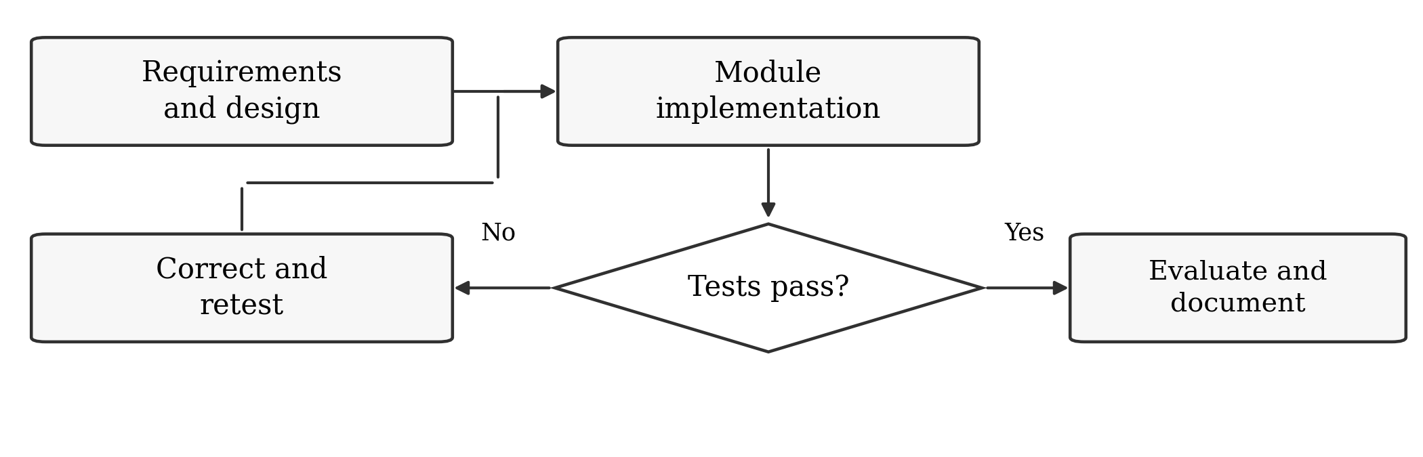
Figure 3. Iterative development methodology
Our acceptance criteria require working project templates, verified cross-origin API communication, blocked push attempts whenever secrets are found, zero unapproved file overwrites, and faithful preset restoration. We document test environments carefully, keeping network download times separate from template generation times so that performance benchmarks remain fair and accurate.

5 REFERENCES
[1] Node.js contributors, “Child process.” Accessed: Oct. 22, 2026. [Online]. Available: https://nodejs.org/api/child_process.html
[2] Microsoft, “node-pty.” Accessed: Oct. 22, 2026. [Online]. Available: https://github.com/microsoft/node-pty
[3] SQLite, “Appropriate uses for SQLite.” Accessed: Oct. 22, 2026. [Online]. Available: https://www.sqlite.org/whentouse.html
[4] Gitleaks contributors, “Gitleaks.” Accessed: Oct. 22, 2026. [Online]. Available: https://github.com/gitleaks/gitleaks
[5] Git contributors, “githooks documentation.” Accessed: Oct. 22, 2026. [Online]. Available: https://git-scm.com/docs/githooks
[6] Vite contributors, “Getting started.” Accessed: Oct. 22, 2026. [Online]. Available: https://vite.dev/guide/
[7] GitHub, “Prompt engineering for GitHub Copilot.” Accessed: Oct. 22, 2026. [Online]. Available: https://docs.github.com/en/copilot/concepts/prompting-and-context/prompt-engineering
[8] OWASP, “LLM02:2025 Sensitive Information Disclosure.” Accessed: Oct. 23, 2026. [Online]. Available: https://genai.owasp.org/llmrisk/llm022025-sensitive-information-disclosure/
[9] Node.js contributors, “File system.” Accessed: Oct. 23, 2026. [Online]. Available: https://nodejs.org/api/fs.html
[10] Python Software Foundation, “venv — Creation of virtual environments.” Accessed: Oct. 23, 2026. [Online]. Available: https://docs.python.org/3/library/venv.html
[11] npm contributors, “npm-install.” Accessed: Oct. 23, 2026. [Online]. Available: https://docs.npmjs.com/cli/v11/commands/npm-install/
[12] FastAPI, “CORS (Cross-Origin Resource Sharing).” Accessed: Oct. 23, 2026. [Online]. Available: https://fastapi.tiangolo.com/tutorial/cors/
[13] Django Software Foundation, “Writing your first Django app, part 2.” Accessed: Oct. 23, 2026. [Online]. Available: https://docs.djangoproject.com/en/5.2/intro/tutorial02/
[14] Git contributors, “git-rebase documentation.” Accessed: Oct. 23, 2026. [Online]. Available: https://git-scm.com/docs/git-rebase
[15] GitHub, “GitHub CLI manual: gh repo create.” Accessed: Oct. 23, 2026. [Online]. Available: https://cli.github.com/manual/gh_repo_create

